Name: _________________________________ Mark: ____________/24

# Physics Unit 4 Evaluation – Weak Nuclear Force Time: 40 minutes

**Materials: Formulae and Data Booklet**

An interaction between half integer spin fermions occurs through the exchange of integer spin bosons – the force mediating particles of the standard model. There are four fundamental interactions (forces) described by the standard model. The weak nuclear force is one of these fundamental forces.

The weak nuclear force is mediated by three distinct types of carrier bosons – the W+, W- and Z bosons with electric charges of +1, -1 and 0 respectively. The weak nuclear force interacts with both quarks and leptons and has the unique behaviour that it can change the flavour of quarks. Most particles of the standard model are unstable and decay into lower mass products, as this lowers the energy any one particle has. The universe always favours reducing the energy-mass any one particle has - a concept called increasing the entropy. The mass of the W and Z bosons are large, even larger than the mass or a proton or neutron. This limits the range of the weak nuclear force because the bosons quickly decay.

The neutron is heavier than the proton, and hence can decay into a proton spontaneously. Energy is conserved as the lower mass of the products is made up for by an increase in kinetic energy of the products. The transformation of the proton is achieved via the weak nuclear force that changes a down flavoured quark into an up flavoured quark. This is shown via the pair of interactions below:

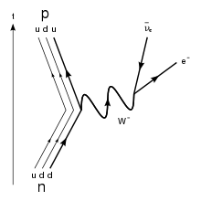

Beta Decay

$d→u+W^{-}$

$W^{-}→e^{-}+\overline{ν_{e}}$

**Net reaction: $d→u+e^{-}+\overline{ν_{e}}$**

Interaction 1 is the first stage of beta decay. To conserve electric charge, a W- boson must be the mediating boson. Interaction 2 of the decay is when W- decays into an electron and anti-electron neutrino. The lost energy due to reduced rest mass becomes kinetic energy of the products.

In positron decay, an up quark can convert into a down quark, emitting a positron and electron neutrino. To conserve electric charge this requires a W+ boson to mediate the interaction. Because a neutron is heavier than a proton, this requires some external energy input for the interaction to proceed. This doesn’t mean the reaction isn’t possible, but does occur less frequently than beta decay because energy must be conserved and it is less likely to be conserved when the products are more massive.

Another interaction of the weak nuclear force is electron capture. This occurs when an electron bound to an atom is ‘absorbed’ by a proton in its nucleus. This converts the proton into a neutron and emits an electron neutrino.

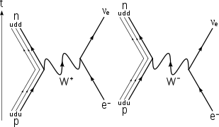

$$net reaction: u+e^{-}→d+ν_{e}$$

Because the electron neutrino is the only product of the decay not bound within the nucleus, it carries the entire energy of the decay, making it travel at very high relativistic speeds. Although the mass of the products (down quark and neutrino) is much smaller than the reactants, this process does not occur often as electrons are often bound to levels far from the nucleus.

In neutral current interactions, a quark or a lepton emits or absorbs a neutral Z boson. An example of a Z boson mediation is the scattering between leptons:

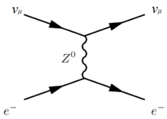



$ν_{μ}→ν_{μ}+Z^{0}$

$Z^{0}+e^{-}→e^{-}$

The lack of charge of the Z boson means it cannot change the flavour of quarks.

**Questions**

**Give all numerical answers to three significant figures.**

1. Name four processes/reactions that the weak nuclear force is responsible for. [4 marks]
   * + 1. ________________________
       2. ________________________
       3. ________________________
       4. ________________________
2. Write **two** (**2**) reactions for the stages of positron decay, clearly showing the involvement of the mediating boson, in the same style as was shown for beta decay in the text.

[4 marks]

1. Show that electric charge is conserved during the **first stage** of the beta decay shown in the text. [2 marks]
2. Calculate the following, using the net reaction for beta decay as a reference:
   1. The combined rest mass of the products of beta decay in MeV/c2. [2 marks]
   2. Hence, calculate the combined maximum kinetic energy of particles produced during beta decay. If you could not obtain an answer to part a), you may assume a value of 3.00 MeV/c2. [3 marks]
3. Explain why beta decay is spontaneous, while positron decay is not. [4 marks]

1. Justify, by referring to conservation laws, the likelihood that alternative versions of beta decay will occur, where a neutron converts to a proton but the products are not an electron and an anti-electron neutrino. Include an example of a reaction that supports your answer. [5 marks]

**End of Questions**